**Azure Functions**

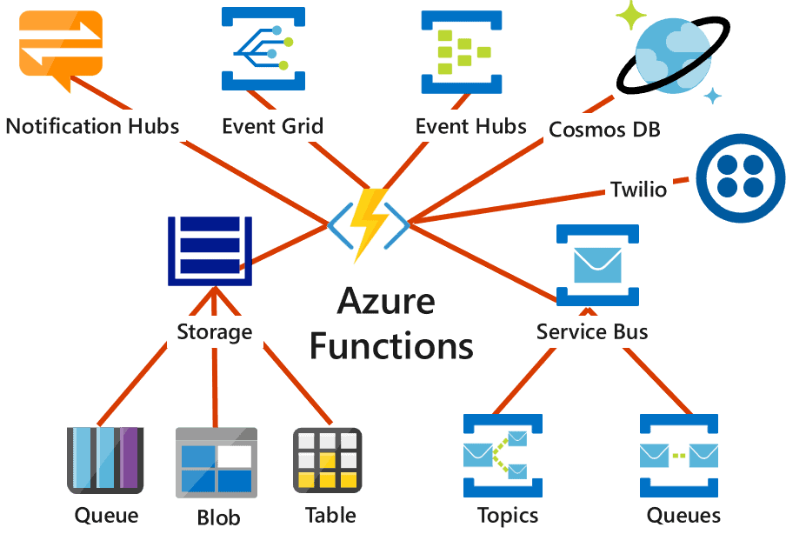

Azure Functions is a **serverless compute service** that lets you run small pieces of code (functions) in response to events without managing infrastructure. It automatically scales and charges only for the compute time your code uses.

Features :

1. **Multiple Language Support** – Supports C#, JavaScript, Python, Java, PowerShell, and more for flexible development.
2. **Auto Scaling** – Instantly scales up or down based on the workload, ensuring efficient performance and cost-effectiveness.
3. **Event-Driven Architecture** – Automatically responds to various Azure or external events like blob updates, Service Bus messages, or API calls.